# SIT107 – 11.1D

### Sprint 2 Data Visualisation Tiffany Gray

### 218518691

### Gregory S McIntyre

### 218356779

<https://github.com/gregorymcintyre/SIT107-Team-Project-Sprint-1>

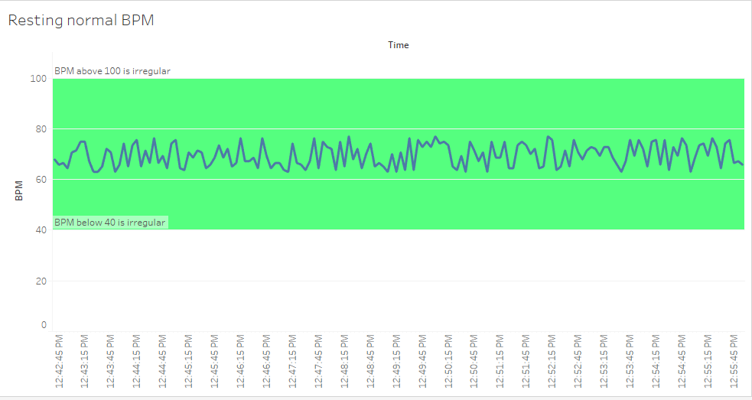

Figure : Regular, resting heart date

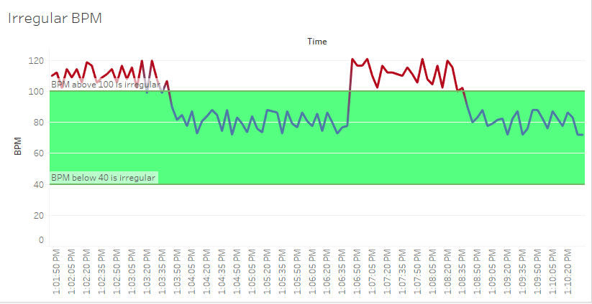

Figure : Irregular, active heart rate